A REACT INTRODUCTION

--> Heart of react app : Components
--> Component : a piece of user interface
--> Building app with react : build a bunch of independent isolated and reusable Component and then compose them to build complex user interfaces
--> Every react app essensially a tree of components
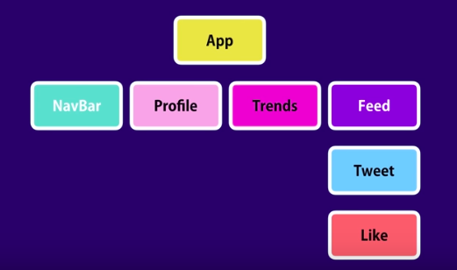
→ App has navbar, profile, tweets and feed
→ Feeds has Tweets
→ Tweets has Likes

--> In term of implementation, the component is typically implemented as js class that has some state and render method.
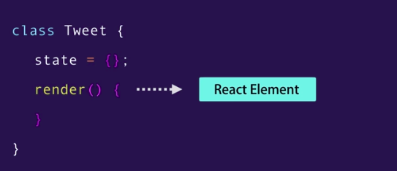
// state : data that we want to display when when the component is rendered
// render method : responsible for describing what the UI should look like
--> Ouput of react render → react element

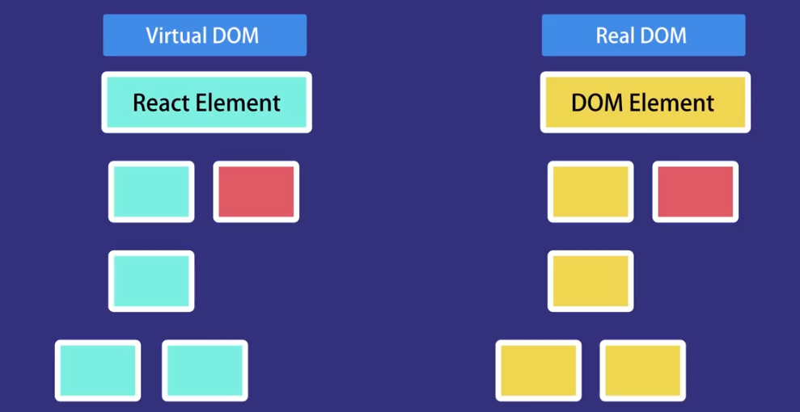
//React element : simple plain js object that maps to a DOM element.
--> It’s not a real DOM element it’s just a plain js object that represents that DOM element in memory.
--> React keeps a lightweight representation of the DOM in memory which we referred to as a virtual DOM. Unlike the browser or the real DOM, this virtual DOM is cheap to create
--> When we change the state of the component, we get a new react element, react will then compare this element and his children with the previous one, it figures out what is changed, and then it will update a part of the real DOM to keep it in sync with the virtual DOM
--> Which means in ract u no longer have to work with the DOM API in browser == we have no longer write code and query and manipulate the DOM or attach the event handlers to DOM element

B HOW TO INSTALL AND WHAT WE GET
--> Langkah2 (fully implementation):
1. install node js
2. npx create-react-app namanya
3. npm start
4. Third party: vs code with react snippet and prettier installed
--> What we get:
1. Development server
2. Webpack : for bunling our file
3. Babel : for compiling our js code
4. Other
--> What we get (in detail) :
1. 3 folder :
a) /node module
b) /public
--> disini ada index.html yg ada <div id=”root”> //disinilah tepat kita meletakkan semua file react yang berasal dari /src
c) /src
--> berisi component2nya yang akan dimasukkan di <div id=”root”>
--> defaultnya ada : app.css, app.js , dll
//app component
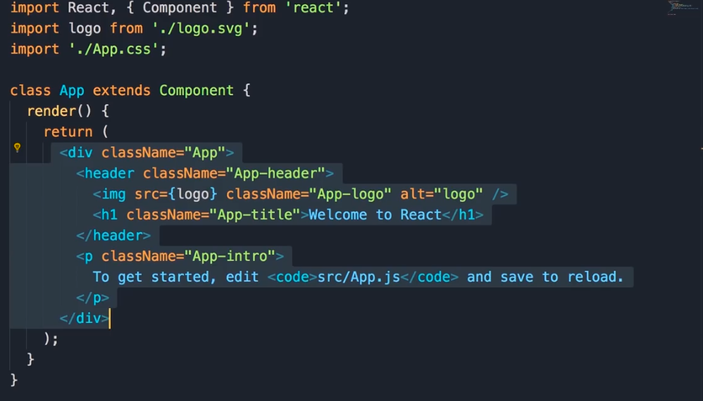
// yang di block itu adalah JSX, kode JSX akan diconvert oleh babel ke plain js code yang browser dapat mengerti
//Syntax JSX mirip2 html dengan perbedaan :

C HELLO WORLD IN REACT
--> Langkah2 :
a) in /src:
1. buat index.js dan isi dengan :
import react from 'react';
//obj //module
import reactDOM from 'react-dom';

conts pertama =<h1> Hello word</h1>; //ini adalah jsx yang merupakan react element dan merupakan bagian dari virtual DOM
ReactDOM.render(pertama, document.getElementById('root')); //gunanya untuk merender jsx tadi ke real DOM
//jsxnya //tempat kita ingin meletakkan react elementnya ke real DOM
//root ada di <div> di /public/index.html
--> Contoh dengan dan tanpa babel:
<h1> Hello word</h1>;
--> Akan menjadi:
React.createElement( //ada 3 argument disini
"h1", //type datanya
null, //attribute
"hello word" //isinya
);

D FIRST REACT COMPONENT
--> Langkah2:
a. Install what u need:
1) npx create-react-app counter-app
2) npm i bootstrap@4.1.1
--> di index.js:
import 'bootstrap/dist/css/bootstrap.css';
b. Tambah Component Pertama:
1) buat dir components di /src, buat file counter.jsx
2) di counter.jsx isi dengan:
import React, {Component} from 'react';

class Counter extends Component {
render() {
return <h1>Hello Word</h1>
//its jsx, aslinya dicompile oleh bible mjdi React.createElement (kaya diatas)
}
};
export default Counter;

3) di index.js tambahin dan ubah:
//import default class Counter
import Counter from './components/counter';
//ubah di DOM utama:
ReactDOM.render(<Counter />, document.getElementById('root'));
//yg akan dieksekusi(disini Counter class)

E EMBEDDING EXPRESSIONS 1
--> Jika element yang ada di jsx lebih dari 1, kita harus membungkusnya di <div> dan return diberi ()
--> Karena argument pertama di React.Component adalah element, jika lebih dari 1 element , React.Element akan bingung
--> exp: //antisipasinya adalah membungkus seluruh element dalam div
return(
<div>
<h1>Hello Word</h1>
<button>Increment</button>
</div>
);
--> Hasilnya:
React.createElement(
"div",
null,
React.createElement(
"h1",
null,
"Hello Word"
),
React.createElement(
"button",
null,
"Increment"
)
);
--> Cara lain jika nggk pengen nambahin <div>, pake <React.Fragment>:
return(
<React.Fragment>
<h1>Hello Word</h1>
<button>Increment</button>
</React.Fragment>
);

E EMBEDDING EXPRESSIONS 2
--> State is special property of react element basically its an object that includes any data that this component needs
--> jsx expressions are like normal js object, u can return them from a function, u can pass them to a function, u can also use them as value of a constant or variable
class Counter extends Component {
state = {
count : 0
};

render() {
return(
<div>
<span>{this.formatCount()}</span>
{/* in that curly brachets u can add any valid javascript expression */}
<button>Increment</button>
</div>
);
}

formatCount(){
/* cara cepat dari this.state.count; */
const {count} = this.state;
return count === 0 ? 'Zero' : count;
/* cara lain */
return count === 0 ? <h1>Zero</h1> : count;
/* ini yng dimaksud : jsx expressions are like normal js object */
}
}

F SETTING ATTRIBUTE
--> Class in jsx is not class but className
--> Inline css in jsx: u must pass the value as an object, to do this the value must be in value of property
--> exp : di class Counter:
state = {
count : 0
};

//inline css in jsx: property
angka ={
fontSize : 23,
//biasanya kan font-size, di jsx formatnya camelCase, dan px nggk perlu ditulis, cukup angkanya aja
fontWeight : "bold"
}

render() {
return(
<div>
<span style={this.angka} className="badge badge-primary m-2">{this.formatCount()}</span>
{/*passing property angka ke inline css */}

{/*jika nggk pengen pake property, bisa langsung taro di dalem, tapi make nya double brachets{{ isi }} */}
<span style={{fontSize:23}} className="badge badge-primary m-2">{this.formatCount()}</span>
<button className="btn btn-secondary btn-sm">Increment</button>
</div>
);
}

G RENDERING CLASSES DINAMICALLY
--> exp: if the value of property is zero, the padding color is yellow, when its not zero it will be blue: langkah2 :
1. add this function to change value of className's <span> based on value count:
ubahWarnaLencana(){
let warna = "badge m-2 badge-";
warna += this.state.count === 0 ? "warning" : "primary" ;
return warna;
}
2. di className <span> ubah valuenya menjadi function ubahWarnaLencana() :
<span className={this.ubahWarnaLencana()}>{this.formatCount()}</span>

H RENDERING LISTS
--> Nampilin semua yang di array menjadi <li>
--> in jsx there is NO LOOP, because jsx is not templating engine, its just simple syntax that eventually get compiled to React.Element
--> caranya: pakai array.map()
--> ract must identify each item in list, therefore we need a key for every item
--> Langkah2:
1) buat array dalam state:
state = {
count : 1,
tag: ['tag1','tag2','tag3']
};
2) di render() : buat <ul><li>, looping pakai array.map(), setiap <li> harus diberi key:setiap key harus unique:
<ul>
{this.state.tag.map((a) => <li key={a}>{a}</li>)}
</ul>

I CONDITIONAL RENDERING
--> Kasus: Jika di array ada isinya nampilin gini, jika nggk ada akan nampilin gitu
--> DI jsx nggk ada loop, conditional statament, dll. Ngatasinnya pake:
1) Buat function di luar render dan panggil fungsinya di dalam render:
a) buat fungsi di luar render yang berisi if else condition:
renderTag(){
if(this.state.tag.lenght === 0) return <p> There is no tag!</p>;
return (
<ul>
{this.state.tag.map((a) => <li key={a}>{a}</li>)}
</ul>
);
}
b) tampilin di render:
{this.renderTag()}
2) Pake combinasi boolean && string:
--> Beda dengan other programming language, u can apply the logical && between boolean value and string
--> exp :
1) true && false //false
2) true && "hai" //hai
3) true && "hai" && "coba" //coba --> diambil yang terakhir
--> implementasi: in render:
{this.state.tag.length === 0 && <p> There is no tag!</p>}

J HANDLING EVENTS
--> Contoh event : onClick(),onHover(), dll
--> Event di react:
1) Syntax :harus camelCase exp: onClick()
2) function di value event harus nggk pake () padahal dia fungsi, exp :
naik() => {} jika dipanggil ke dalam event menjadi : onCLick =(this.naik)
3) Ada hal istimewa di event,fungsi "this" pada event, reference ke window browser, karena dia stand-alone function klo di event
--> exp:
1) di render :
<button onClick={this.naik} className="btn btn-secondary btn-sm">Increment</button>
2) di event function :
naik(){
this.state.count += 1; //hasil error property 'state' is undefined
}
--> Cara mengatasi ? ya di bind, cara ? go to next chapter

K BINDING EVENT HANDLERS
--> class di react, cuma boleh diisi, function, state, dan render, dan kita nggk bisa ngasih variable, jadi kita nggk bisa di luar function buat binding :
let a = this.state.count.bind(this);
--> Solusi:
1) Pake constructor buat dapetin "this" punya class :
constructor(){
super();
this.naik = this.naik.bind(this);
//kenapa harus dimasukin di variable ? jawaban dibawah
//this.naik = --> di ngeset fungsi naik yang ada di class Counter
//this.naik.bind(this); --> nge bind 'this' punya naik agar selalu reference ke "this" punya Counter
}
2) Pake arrow function, tapi bakal deprecated di update selanjutnya:
naik = () => {
console.log(this.state.count); //hasil: sesuai nilai countnya
}
//lihat cara penulisan arrrow function, dia ada dalam variabel bernama naik

L UPDATING THE STATE
--> we cant update the value of property directly, exp:
--> di fungsi naik() kita kasih : this.state.count += 1; //ini nggk bakal work
--> di console terupdate, tapi react doesnt notice it, kenapa?
--> React pake virtual dom, jadi agar statenya terupdate kita pake method bawaan class Componet yaitu setState()
--> setState() : method ini memberi tahu react klo kita sedang mengupdate state, method lalu mensykronkan perubahan di virtual dom ke dom sebenarnya
--> exp:
naik = () => {
this.setState({ count : this.state.count + 1})
}

M WHAT HAPPENS WHEN STATE CHANGES
pass

N PASSING EVENT ARGUMENTS
--> kan method di eventHandler nggk ada tanda kurung (), trs gimana jika kita pengen ngasih argument?
--> ada 2 cara?
1) mbikin fungsi baru, buat ngisi argument, caranya:
a) buat fungsi dan fungsi yg berisi argument:
naik = (arg) => {
//arg --> parameter
console.log(arg);
//apa yg dilakuin fungsi terhadap argument, disini cma console.log();
this.setState({ count : this.state.count + 1})
}

argNaik = () =>{
this.naik("isi argument");
//masukin argumentnya disini
}
b) Panggil fungsi yang udah berisi argument:
<button onClick={this.argNaik} className="btn btn-secondary btn-sm">Increment</button>
2) Pake inline function:
--> mirip sama cara 1, tapi dijadiin inline aja fungsinya :
a) Mbikin fungsinya
naik = (arg) => {
//kasih argument dan apa yg pengen dilakuin fungsi terhadap argument tsb
console.log(arg);
this.setState({ count : this.state.count + 1})
}
b) Manggilnya

<button onClick={() =>this.naik('isi argument')} className="btn btn-secondary btn- sm">Increment</button>
//wrapping fungsi naik() dalam onClick langsung

